1 : Use ps to search for the “systemd” process by name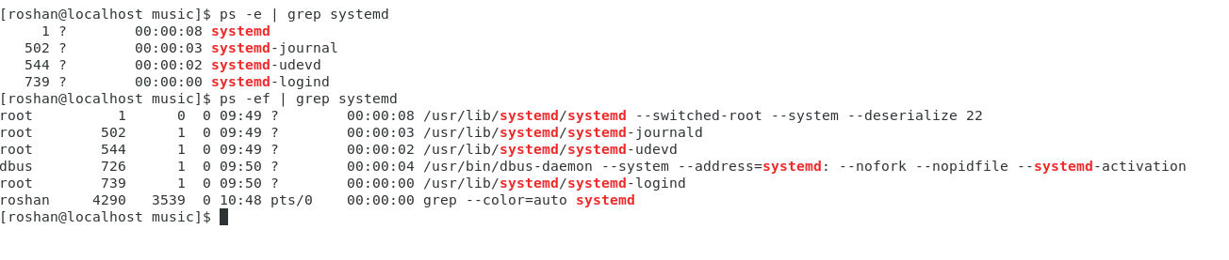

2 : Find out your terminal name. Using your terminal name, use ps to find all processes associated with your terminal.

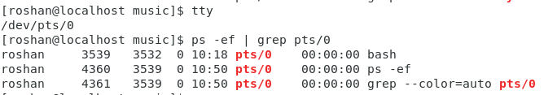

3 : Check and note the process id of your shell (from the output of the above command) Also, note the parent process id of your shell

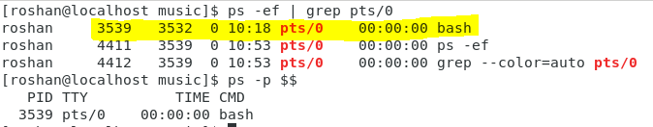

4 : Start 3 instances of “sleep 123” as background processes

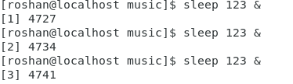

5: Check and note the process id’s of all sleep processes

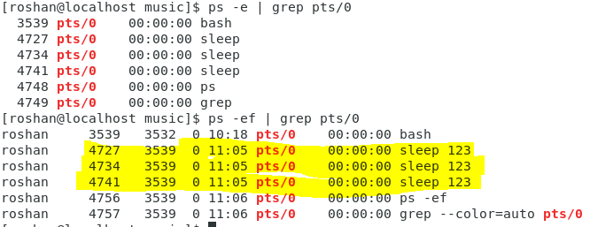

Process id: 4727,4734,4741